**Steps to add “content” and “tags” collection**

1. Add a new collection to the database

1. Select the collection and click on “Add Data – Import File ”

1. Click on csv and select the content file change the **PCO_NUM to int32**

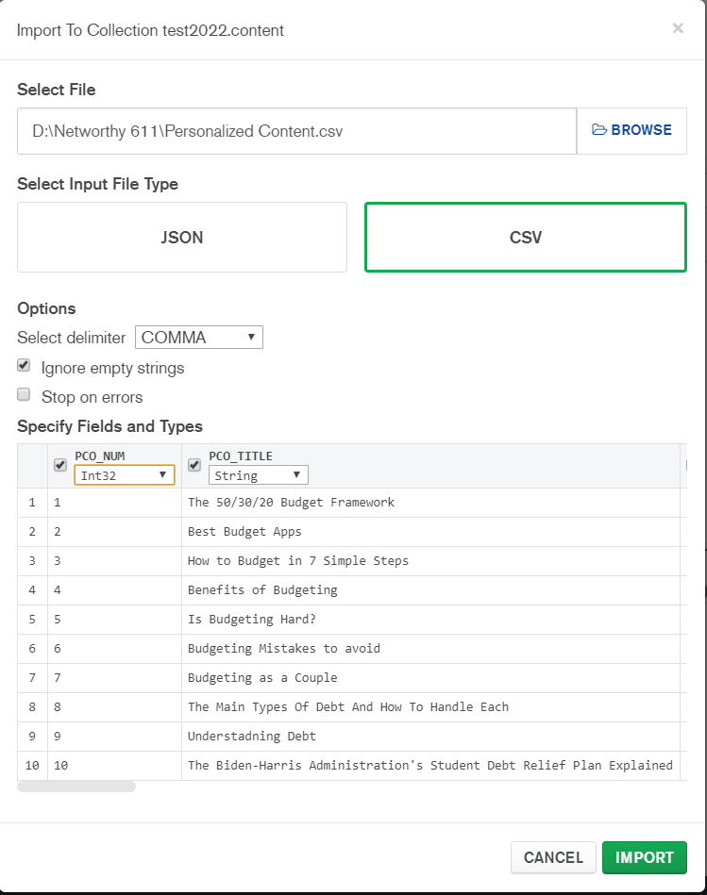

1. Click on Import and Done

